Assignment
Fundamental Theory
(LAB: 10)
NAME: Majid Ali
CMS ID: 053-25-0017
PROGRAM: Software engineering (Section: A)

Q 1:
Write a C++ program where you should ask the use to input a date in the format DD/MM/YYYY (like 26/01/2022) where day, month, and year are separated by a slash. Then, print day or date, month, and year on a separate line (like 26 should be printed on one line, 01 on the second line, and 2022 on the third line)
#include <iostream>
#include <string>
using namespace std;

int main(){
string date;
cout<<"Enter the Date: ";
cin>>date;
cout<<"Date: "<<date.substr(0,2)<<endl;
cout<<"Month: "<<date.substr(3,2)<<endl;
cout<<"Year: "<<date.substr(6,7)<<endl;
return 0;
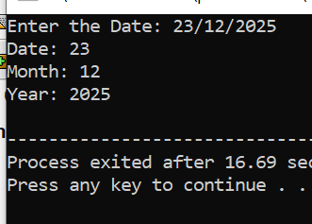
}

Q 2:
Create a user-defined function that should take one string parameter and it should return an integer value: the count or number of words in that string. Then, call it in the main ( ), where you should ask the user to enter any string value (can be an entire line), pass that value to the function being called, and display the returned value.
#include <iostream>
#include<string>
using namespace std;
int count(string arr){
int value=arr.length();
return value;
}
int main(){
string arr;
cout<<"Enter the sentence: ";
getline(cin,arr);
cout<<"Number of words: "<<count(arr)<<endl;;
return 0;
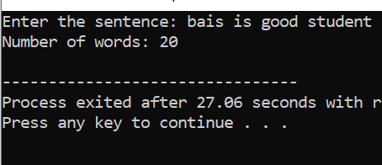
}

Q 3
Write a C++ program that should ask the user to input a phone number where the network and number are separated by a dash “-” like 0300-1234567. Then, print which network is used in that number. For simplicity, assume the following codes are used by the respective networks:
#include <iostream>

using namespace std;

int main(){
string network[4][2]={{"0300","moblink"},{"0333","Ufone"},{"0315","Zong"},{"0345","Telenor"}};
string phonenumber;
cout<<"Enter the phonenumber: ";
cin>>phonenumber;
string code= phonenumber.substr(0,4);
bool found=false;
for(int i=0; i<4; i++){

if (network[i][0]==code){
cout<<"Network: "<<network[i][1]<<endl;
bool found=true;

break;
}
}
return 0;
}
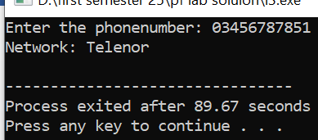

Q 4:
Write a C++ program where you should ask the user to input his/her first and last names and create/print an @iba-suk.edu.pk email address with the entered first name and last name. For example, if the first name is zainab and last name is umair, then the program should make and print zainab.umair@iba-suk.edu.pk email address.
#include <iostream>
#include<string.h>
using namespace std;
int main(){
char name1[20],name2[20],name3[20]="@gmail.com";
cout<<"Enter the name1: ";
cin>>name1;
cout<<"Enter the name2: ";
cin>>name2;
strcat(name1,name2);
strcat(name1,name3);
cout<<"Gmail: "<<name1<<endl;
return 0;
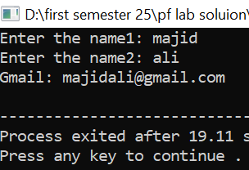
}

Q 5:
Create your own user defined function my_lower( ) that takes one string parameter and return a string. The function should convert all the character in the string passed through arguments to lowercase. Then, call that function in the main ( ) function where you should ask the user to input a string, pass that string to the function created by you, and display the result returned by your function.
#include <iostream>
#include <string>
using namespace std;

string my_lower(string str) {
for (int i = 0; i < str.length(); i++) {

if (str[i] >= 'A' && str[i] <= 'Z') {
str[i] = str[i] + ('a' - 'A');
}
}
return str;
}

int main() {
string input;

cout << "Enter a Uppercase: ";
getline(cin, input);

string lowerStr = my_lower(input);

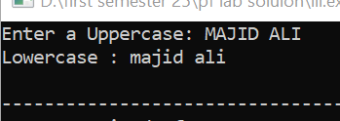
cout << "Lowercase : " << lowerStr << endl;

return 0;
}
Q 6:
Create your own user defined function my_upper( ) that takes one string DEPARTMENT OF COMPUTER SCIENCE, SUKKUR IBA UNIVERSITY 16 PREPARED BY: ENGR. ZAINAB UMAIR parameter and return a string. The function should convert all the character in the string passed through arguments to uppercase. Then, call that function in the main ( ) function where you should ask the user to input a string, pass that string to the function created by you, and display the result returned by your function. 7. Write a program to check if a string (input by the user) is palindrome or not. A palindrome string is the one that reads the same if you read from backward or from forward, like madam, radar, civic, anna, bob, refer an
#include <iostream>
#include <string>
using namespace std;

string my_upper(string str) {
for (int i = 0; i < str.length(); i++) {

if (str[i] >= 'a' && str[i] <= 'z') {
str[i] = str[i] - ('a' - 'A');
}
}
return str;
}

int main() {
string input;

cout << "Enter a string: ";
getline(cin, input);
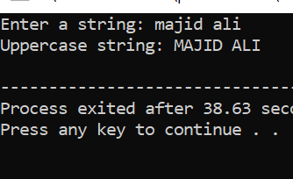
string upperStr = my_upper(input);

cout << "Uppercase string: " << upperStr << endl;

return 0;
}
Q 7:
Write a program to check if a string (input by the user) is palindrome or not. A palindrome string is the one that reads the same if you read from backward or from forward, like madam, radar, civic, anna, bob, refer and so on.
#include <iostream>
#include <cstring>

using namespace std;

int main() {
char name1[50];
cout << "Enter a name: ";
cin >> name1;
string change = strrev(name1);
cout << "Reverse: " << change << endl;
int value = strcmp(name1, change.c_str());

if (value == 0) {
cout << "Palindrome" << endl;
}
else {
cout << "Not Palindrome" << endl;
}

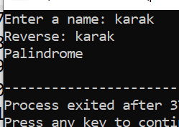
return 0;
}

Q 8:
Write a program Ask the user to input a sentence as a string. Then, count the occurrences of the character that appears at the beginning of your first name and the character that appears at the beginning of your last name in a given text. In other words, the program should count how many times these two specific characters appear in the text. Say suppose my full name is Zainab Umair, then program must count the occurrences of ‘z’ and ‘u’.
#include <iostream>
#include <string>
using namespace std;

int main() {
string sentence;
string firstName, lastName;

cout << "Enter your first name: ";
cin >> firstName;
cout << "Enter your last name: ";
cin >> lastName;
char firstChar = tolower(firstName[0]);
char lastChar = tolower(lastName[0]);

cin.ignore();

cout << "Enter a sentence: ";
getline(cin, sentence);
int countFirst = 0, countLast = 0;
for (int i = 0; i < sentence.length(); i++) {
char ch = tolower(sentence[i]);
if (ch == firstChar) countFirst++;
if (ch == lastChar) countLast++;
}

cout << "Occurrences of '" << firstChar << "': " << countFirst << endl;
cout << "Occurrences of '" << lastChar << "': " << countLast << endl;
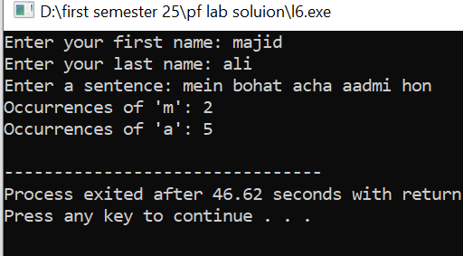
return 0;
}

Q 9:
Develop a program that combines two strings and removes any duplicate characters. How would you implement this efficiently? Make and initialize two arrays to save first and last name then develop a third array of full_names by concatenating each array element. Say suppose, first_names={"Zainab", "Urooj", "Umair"} and last_names = {"Kamangar", "Chan" , "Kamangar"}, then the full_names will be {"Zainab Kamangar", "Urooj Chan", "Umair Kamangar"}
#include <iostream>
#include <cstring>
using namespace std;

int main() {
char first_names[3][20] = {"Zainab", "Urooj", "Umair"};
char last_names[3][20] = {"Kamangar", "Chan", "Kamangar"};
char full_names[3][40];

for (int i = 0; i < 3; i++) {
strcpy(full_names[i], first_names[i]);
strcat(full_names[i], " ");
strcat(full_names[i], last_names[i]);
}
for (int i = 0; i < 3; i++) {
char unique[40] = "";
int len = strlen(full_names[i]);
int index = 0;

for (int j = 0; j < len; j++) {
char ch = full_names[i][j];
bool found = false;
for (int k = 0; k < index; k++) {
if (unique[k] == ch) {
found = true;
break;
}
}
if (!found) {
unique[index++] = ch;
}
}
unique[index] = '\0';
strcpy(full_names[i], unique);
cout << "Full names with unique characters:" << endl;
for (int i = 0; i < 3; i++) {
cout << full_names[i] << endl;
}
}
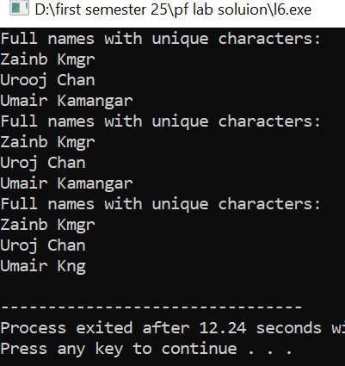
return 0;
}

Q 10:
Create a program that searches for a specific substring within a larger text and returns the position of the first occurrence. How would you handle multiple occurrences?
#include <iostream>
#include <cstring>
using namespace std;

int findSubstring(char text[], char pattern[]) {
int n = strlen(text);
int m = strlen(pattern);

for (int i = 0; i <= n - m; i++) {
int j;
for (j = 0; j < m; j++) {
if (text[i + j] != pattern[j]) {
break;
}
}
if (j == m) {
return i;
}
}
return -1;
}

int main() {
char text[1000], pattern[100];

cout << "Enter the text: ";
cin.getline(text, 1000);

cout << "Enter the target to search: ";
cin.getline(pattern, 100);

int pos = findSubstring(text, pattern);

if (pos != -1) {
cout <<"Target found at "<<pos<<endl;}
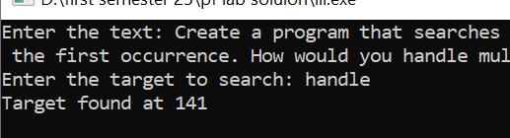
return 0;
}

Q 11:
String, Loop and Conditional - Password Validation You are tasked with creating a user account management system for a secure application. To ensure user account security, you need to implement a password validation system. Write a C++ program that performs the following tasks: Ask the user to create a new account by entering a username and password. Implement password validation with the following criteria: • Password should be at least 8 characters long. • It must contain at least one uppercase letter. • It must contain at least one lowercase letter. • It must contain at least one digit. • It must contain at least one special character (e.g., !, @, #, $, etc.). If the entered password meets the criteria, display a message indicating that the account has been created successfully. Otherwise, provide feedback to the user on which criteria were not met.
#include <iostream>
#include <string>
using namespace std;

void validatePassword(string password) {
bool hasUpper = false;
bool hasLower = false;
bool hasDigit = false;
bool hasSpecial = false;
bool validLength = password.length() >= 8;

for (int i = 0; i < password.length(); i++) {
char ch = password[i];
if (ch >= 'A' && ch <= 'Z') hasUpper = true;
else if (ch >= 'a' && ch <= 'z') hasLower = true;
else if (ch >= '0' && ch <= '9') hasDigit = true;
else hasSpecial = true;
}

if (!validLength) cout << "Password must be at least 8 characters long." << endl;
if (!hasUpper) cout << "Password must contain at least one uppercase letter." << endl;
if (!hasLower) cout << "Password must contain at least one lowercase letter." << endl;
if (!hasDigit) cout << "Password must contain at least one digit." << endl;
if (!hasSpecial) cout << "Password must contain at least one special character." << endl;

if (validLength && hasUpper && hasLower && hasDigit && hasSpecial) {
cout << "Account created successfully!" << endl;
} else {
cout << "Please try again with a stronger password." << endl;
}
}

int main() {
string username, password;

cout << "Create a new account" << endl;
cout << "Enter username: ";
cin >> username;
cin.ignore();
cout << "Enter password: ";
getline(cin, password);

validatePassword(password);

return 0;
}
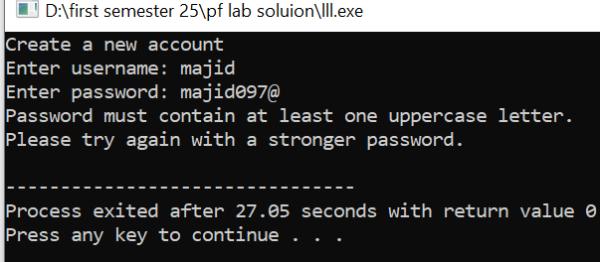

Q 12:
Text Message Filtering You are developing a text message filtering system for a messaging app. Your goal is to create a program that allows users to send messages while filtering out inappropriate words. You need to implement a system that checks each message for banned words and replaces them with asterisks (*) before sending. Write a C++ program that does the following: • Ask the user to input a text message. • Implement a filtering system that checks the message for banned words from a predefined list. You can start with words like "profanity," "spam," or any words you prefer. • If any banned words are found in the message, replace them with asterisks (*) to censor them. • Display the filtered message to the user.

#include <cstring>
using namespace std;

void filterMessage(char message[], char bannedWords[][20], int bannedSize) {
int msgLen = strlen(message);

for (int k = 0; k < bannedSize; k++) {
int wordLen = strlen(bannedWords[k]);

for (int i = 0; i <= msgLen - wordLen; i++) {
int j;
for (j = 0; j < wordLen; j++) {

if (message[i + j] != bannedWords[k][j]) {
break;
}
}
if (j == wordLen) {

for (int t = 0; t < wordLen; t++) {
message[i + t] = '*';
}
}
}
